OSINT and Phishing



Students: ‘Ayham Ghabra, 489306’ and ‘Nawras Almousa, 414237’

Course: OSINT & Social Engineering

Assignment: Assignment 1 – OSINT & Phishing

Company: AEGON

Group: 1

Abstract
This assignment explores the use of Open Source Intelligence (OSINT) and social engineering techniques in the context of organizational security. The objective of the assignment is to examine how publicly available information about a company and its employees can be collected and used to support realistic social engineering and phishing scenarios. Using an ethical and structured OSINT approach introduced during the course, reconnaissance was conducted on the company AEGON. This resulted in the identification of several company-level and employee-level information flags. Based on these findings, a plausible social engineering pretext and a spear-phishing email were developed. The results show that even limited publicly accessible information can significantly increase the credibility of targeted attacks. In the discussion, the extent to which the assignment objectives were achieved is reflected upon, including one identified success and one area for improvement.

1. Orientation
AEGON is a multinational financial services company headquartered in the Netherlands, operating internationally in the areas of life insurance, pensions, and asset management. As a financial institution, AEGON operates in a highly regulated environment and processes large volumes of sensitive personal and financial data.
To support its business activities, AEGON relies on a complex ICT environment consisting of internal enterprise systems, customer-facing digital platforms, secure communication tools, and data storage solutions. Due to its international presence, the organization also supports remote and hybrid working models and depends on various third-party service providers.
The size of the organization, the complexity of its ICT landscape, and its reliance on external parties make AEGON a relevant target for OSINT and social engineering analysis. Publicly available information about these aspects can be misused to create realistic and convincing social engineering scenarios.

2. Collecting Company Flags

Flag 1 – Use of Microsoft 365 for Email and Collaboration
What
AEGON uses Microsoft 365, including Outlook and Microsoft Teams, for internal email communication and collaboration.
Where
This information was identified in public AEGON job vacancies and LinkedIn profiles of AEGON employees, where Microsoft 365 and Teams are frequently mentioned as required skills.
Risk Analysis
An attacker could impersonate internal IT support or a Microsoft partner and send convincing phishing emails related to account issues, password resets, or security updates.
Mitigation
AEGON could reduce this risk by regularly training employees to verify IT-related communications and by clearly communicating how legitimate IT messages are distributed.

Flag 2 – Hybrid and Remote Working Policy
What
AEGON supports hybrid working, allowing employees to work both remotely and from the office.
Where
This information is stated on AEGON’s public careers website and in multiple job postings describing flexible or hybrid working arrangements.
Risk Analysis
Employees working remotely are more dependent on email and digital communication, making them more vulnerable to phishing and impersonation attacks.
Mitigation
Clear procedures for verifying sensitive requests and additional security awareness training focused on remote work scenarios could reduce this risk.

Flag 3 – Use of External IT Service Providers
What
AEGON outsources parts of its IT services and infrastructure to external service providers and consultants.
Where
This information is available in AEGON annual reports and public statements about partnerships with IT and consultancy firms.
Risk Analysis
Attackers could pose as employees of trusted third-party suppliers to gain information or persuade employees to perform unsafe actions.
Mitigation
AEGON could enforce strict supplier verification procedures and ensure employees know how to validate communications from external partners.

Flag 4 – International and Multi-Office Organization
What
AEGON operates internationally with offices in multiple countries and regions.
Where
This information is publicly available on AEGON’s corporate website and in annual reports describing global operations.
Risk Analysis
Emails or requests that appear to originate from international offices may be harder for employees to verify, increasing the success rate of social engineering attempts.
Mitigation
Standardized communication channels and employee awareness of cross-border social engineering tactics can help reduce this risk.

Flag 5 – Use of Cloud-Based Infrastructure
What
AEGON makes use of cloud-based infrastructure and services to support its ICT environment and business operations.
Where
This information was identified through publicly available job vacancies and corporate information describing modern IT environments and cloud adoption.
Risk Analysis
An attacker could impersonate internal IT staff or a cloud service provider and send phishing emails related to system updates, access issues, or security incidents.
Mitigation
AEGON could limit the amount of technical detail shared in public job postings and ensure employees are trained to verify IT-related communications through official channels.
Mitigation
AEGON could limit the amount of technical detail shared in public job postings and ensure employees are trained to verify IT-related communications through official channels.

3. Employee Profile

Selected Employee
Name: Sietske Creyghton
Company: AEGON
Position: Financial Team Lead
The employee was selected based on publicly available professional information.

Personal Flag 1 – Job Role and Responsibilities
What
The employee holds a leadership position within a financial team at AEGON. Her responsibilities include overseeing financial reporting activities and supporting team members in their professional development.
Where
This information was obtained from publicly available professional profile information.

Personal Flag 2 – Length of Employment
What
The employee has been employed at AEGON for approximately four years, indicating familiarity with internal processes and organizational structure.
Where
This information was derived from publicly available employment history data.

Personal Flag 3 – Training and Professional Development
What
The employee has attended a Microsoft-focused professional training or masterclass within the past year.
Where
This information was obtained from publicly shared professional or training-related information.

Personal Flag 4 – Work Location
What
The employee primarily works from the office, with no strong public indicators of frequent remote work.
Where
This was inferred from publicly available professional information and the absence of references to remote or hybrid work.

Personal Flag 5 – Contact Information
What
AEGON uses a standardized corporate email format consisting of first name and last name followed by the company domain.
Where
This format can be observed through publicly available contact information of AEGON employees.

Combined Employee Profile
The selected employee is an experienced financial team lead who has been employed at AEGON for several years. She plays an important role within her department by overseeing financial reporting activities and supporting other employees. Her participation in Microsoft-related training indicates familiarity with enterprise tools commonly used for data analysis and reporting.
From a social engineering perspective, this profile is relevant because communications referencing financial reporting, internal training, or Microsoft-based tools are likely to appear credible. The employee’s leadership role and experience may increase trust in messages that appear to originate from internal departments or trusted external partners.
This analysis is presented strictly for educational purposes and demonstrates how publicly available employee information can be misused if proper verification and security awareness measures are not followed.

4. Pretext – Social Engineering Attempt

Who & Who
I am a representative of a Microsoft-certified training partner that previously delivered a Microsoft Power masterclass to AEGON employees. I am contacting Sietske Creyghton, a financial team lead at AEGON. She is an experienced employee who leads a financial team, prepares financial reports, mentors new employees, and regularly works with Microsoft Power tools as part of her daily responsibilities.

Why
I initiated contact to follow up on the Microsoft Power masterclass that the employee attended approximately ten months ago. The stated reason for contacting her is to inform her about updated reporting templates and training materials that are being distributed to financial team leads following recent updates to Microsoft Power tools.

What
The objective of this pretext is to obtain confirmation about the Microsoft Power tools and reporting templates currently used by the financial team. Additionally, the goal is to persuade the employee to open a document or access a link that is presented as updated training or reporting material related to her previous masterclass.

Questions & Answers
During the interaction, I would ask questions such as:
- Whether she is still using Microsoft Power tools for financial reporting
- Whether she is responsible for reviewing or distributing reporting templates within her team
- Whether her email address can be confirmed to ensure she receives the updated materials
These questions are directly related to her role and prior training and are designed to appear legitimate and routine.

Context
The contact would be initiated via email during regular office hours. Email is a realistic communication channel for external training partners and aligns with the employee’s office-based working environment and professional communication habits.

Chance of Success
The likelihood of success of this pretext is relatively high. The scenario is credible because it is based on verified personal flags, such as the employee’s attendance at a Microsoft Power masterclass, her leadership role within the financial team, and her responsibility for financial reporting. The pretext aligns closely with her professional duties, making the communication appear relevant and legitimate.
However, the pretext could fail if the employee verifies the request with internal IT or Microsoft directly, notices inconsistencies in the sender’s email domain, or follows strict internal verification procedures. Strong security awareness and clear validation processes would significantly reduce the effectiveness of this approach.

5. Phishing Email

Sender Email Address
training.support@ms-power-partner.com

Email Content
Subject: Updated Microsoft Power Reporting Templates – Action Required
Dear colleague,
Following the Microsoft Power masterclass delivered to AEGON financial team leads last year, we are currently distributing updated reporting templates. These updates reflect recent changes within Microsoft Power tools and are intended to improve reporting consistency and performance.
As part of your role in financial reporting and team coordination, we kindly ask you to review the attached document to confirm compatibility with your current reporting workflow.
If you have any questions or require further clarification, please do not hesitate to reply to this email.
Kind regards,
Microsoft Power Training Support
Microsoft Certified Training Partner

Why This Spear-Phishing Attempt Is Expected to Be Effective
This spear-phishing attempt is expected to be effective because it is highly targeted and closely aligned with verified personal and company flags. The email references a real training event previously attended by the employee and uses terminology relevant to her role as a financial team lead. The sender identity appears legitimate by posing as a Microsoft-certified training partner, which aligns with her familiarity with Microsoft Power tools. Additionally, the email content is professional, relevant, and non-urgent, reducing suspicion.

Payload Delivery Method (Descriptive)
In a real-world scenario, the payload could be delivered via a malicious document attachment disguised as an updated reporting template. This method is chosen because documents are commonly exchanged in financial reporting contexts and are therefore less likely to raise immediate concern. For the purposes of this assignment, this is described only at a conceptual level, without implementing or executing any malicious code.

Conclusion
This assignment demonstrates how publicly available information can be systematically collected and combined to support realistic social engineering scenarios. By conducting OSINT on AEGON, several company-level and personal flags were identified that could potentially be exploited by an attacker. These flags formed the foundation for creating a coherent employee profile, a credible pretext, and a targeted spear-phishing email.
The analysis shows that even experienced employees in professional environments can be targeted when an attacker carefully aligns their approach with organizational practices and individual responsibilities. The constructed pretext and phishing email illustrate how trust in familiar tools, external partners, and routine processes can be leveraged to increase the likelihood of success.
At the same time, the assignment highlights the importance of strong security awareness, verification procedures, and clear internal communication policies. By understanding how OSINT and social engineering attacks are designed, organizations and employees can better recognize suspicious behavior and reduce the risk of successful attacks.
Overall, this assignment emphasizes that cybersecurity is not only a technical challenge but also an organizational and human one, where awareness and critical thinking are essential defenses.

Sources:
name | position | email | Birthdate | Extra information
Frans de Beaufort | Global Head Of Corporate Sustainability | frans.debeaufort@aegon.com |  | Available on LinkedIn
Jurgen Spieker | Head of capital management at Aegon | jurgen.spieker@aegon.com |  | Live in Oegstgeest+ Available on LinkedIn and Facebook
Peter Os | Vice president of human resources | peter.os@aegon.com | Sep 1970 | Available on LinkedIn
Tiemen de vries | Chief Compensation and Benefits Officer | tiemen.devries@aegon.com |  | Available on LinkedIn
Elisabetta Caldera | Chief Human Resources Officer | elisabetta.caldera@aegon.com | 1970 | Available on LinkedIn
Sietske Creyghton-Preenen | Head of Financial Operations | sietske.creyghton@aegon.com |  | Available on LinkedIn

Computable — “Aegon scoort met dataplatform in de cloud.” (Published 04-07-2022). https://www.computable.nl/2022/07/04/aegon-scoort-met-dataplatform-in-de-cloud/
CloudCrafter — “Aegon Datalake” (Project page). https://www.cloudcrafter.nl/projects/aegon-datalake/

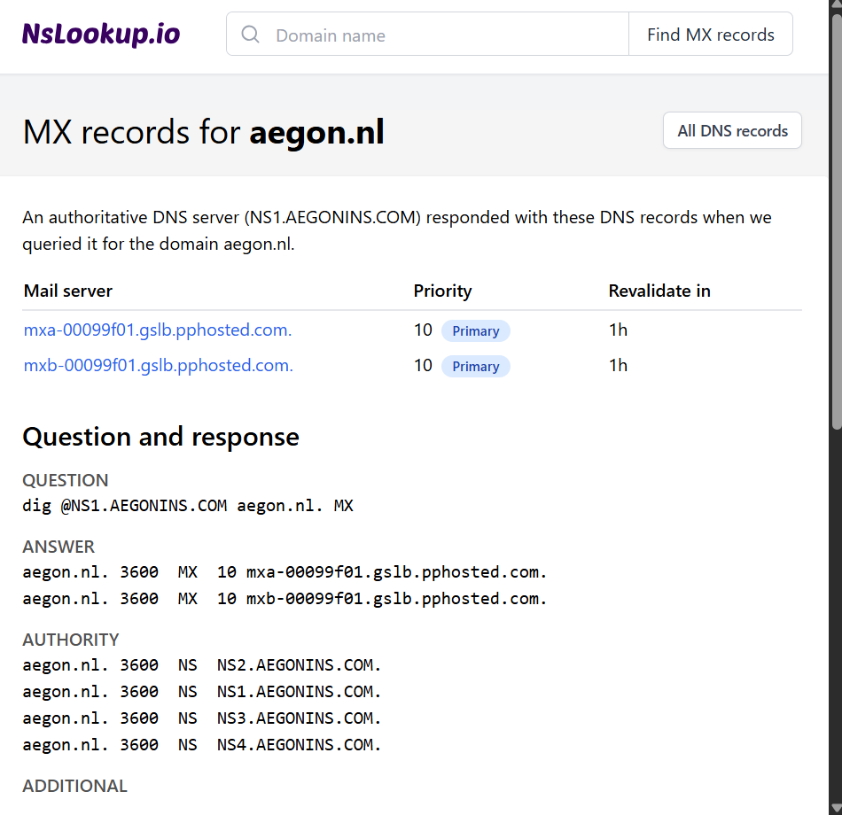
MX records for aegon.nl showing pphosted.com (indicator of external email gateway).
VerifiedEmail — Email verification result for sietske.creyghton@aegon.nl
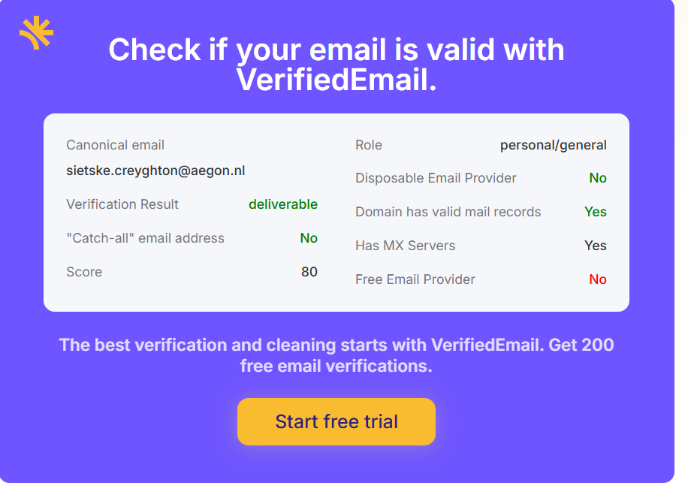
Email verification result for sietske.creyghton@aegon.nl marked as deliverable.

